*Classification Metrics*

*Accuracy & Confusion Matrix*

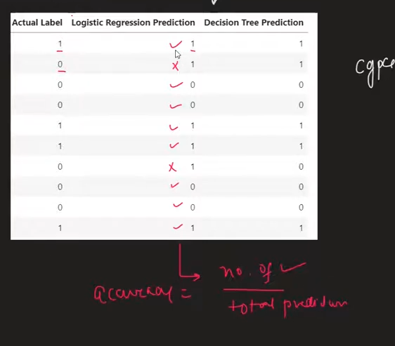

*Accuracy of Logistic Regression =*

*No. of Correct prediction / Total No. of Prediction*

*8/10 = 80% accurate hai.*

*Accuracy of Decision Tree =*

*No. of Correct prediction / Total No. of Prediction*

*9/10 = 90% accurate hai.*

***from sklearn.metrics import accuracy_score***

*Yaha above Example mai hummne Binary Classification ki baat ki hai Binary classification matlab bss 2 Classification hai.*

*Multiclass Classification mai Hum kaise Accuracy Nikalte hai pata karna hai*

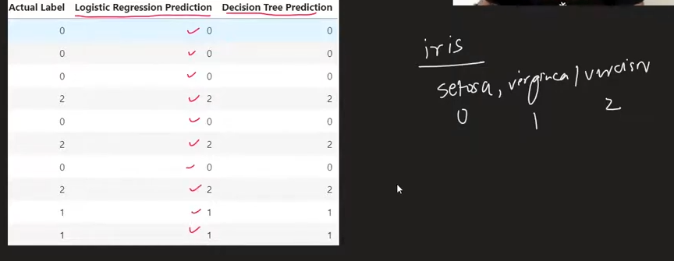

*Accuracy = No. of correction prediction / Total Prediction = 10/10 = 1*

*Conclusion: Dono mai tarika Same hai*

*Let’s Deep Dive now!*

*Interview Question:*

*How Much Accuracy Score is Enough ???*

* *It Depends on the problem we are solving*

*E.g Hospital mai System banarahe hai ki*

*Chest ka Image scan krke batarahe hai ki Cancer hai ki nahi*

*& Maanlo Accuracy 99% hai iski*

* *It Depends on problem we are solving & data pe depend karega*

*Accuracy Metrics Turant acha hai yeah batanekeliye ki Humara Model kaisa perform krrha*

*But there is 1 problem*

*What’s that Problem ?*

*Accuracy yeah nahi batata ki Galti ka type kya hai aapke*

*Jaise humara model suppose 90 % accurate hai*

*Yeah pata challgaya*

*But Humme Yeah nahi pata chalta ki Humm Galti kaha karrhe hai ??*

*Jo 10 % galti hai vo humm kaha krrhe hai ??*

*Yeahi Problem Rectify karnekeliye*

*Dusra Metric aata hai 🡪 that’s Confusion Matrix*

*Confusion Matrix*

***from sklearn.metrics import confusion_matrix***

*E.g:*

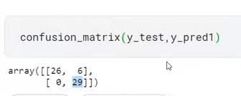

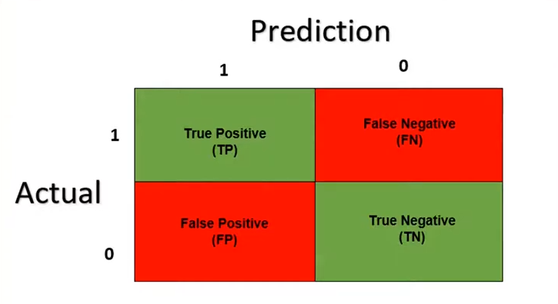

*It is a way to tell ki Humara Model kaha kaise galti krrha hai*

*Confusion Matrix galtiyo ka Nature & type bhi batata hai.*

*Jo Pehla True ya False hai vo Actual Dataset pe Depend krta hai*

*&*

*Jo Positive & Negative hai Vo Model ke prediction pe*

*E.g*

*True Positive:*

*Actual mai Data positive hai & Prediction bhi Positive hai*

*True Negative:*

*Actual mai Data positive hai & Prediction pr Negative aaya hai*

*False Negative:*

*Model ne Positive bola but Theah Vo Negative Reality mai*

*True Negative*

*Model ne Negative bola & Sachmai vo Negative Nikle*

*Jo 1st Word hota that represent Actual Value ko*

*&*

*Jo 2nd Word hota hai that represent Prediction value*

*Confusion Matrix se Accuracy Prediction Nikallna:*

*Accuracy = Number of Correct Prediction / Total Number of Prediction*

*Accuracy of CM:*

*True Positive + True Negative*

*True Positive + True Negative + False Positive + False Negative*

*Type 1 Error & Type 2 Error:*

*Number of False Positive 🡪 Type 1 Error*

*Agar Prediction galat hai As per Actual data then it is type 1 error*

*Agar Prediction ne “Naa” Bola & sachmai “Haa” tha then Type 2 Error*

*Number of False Negative -> Type 2 Error*

*Agar Prediction ne “haa” Bola & sachmai “Naa” tha then Type 2 Error*

*If Multi Class Classification Problem hai then Confusion matrix kaisa dikhega ?*

*E.g:*

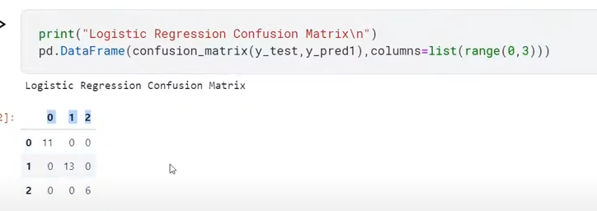

*When Accuracy is Misleading ?*

*Imbalanced Dataset ke time pe misleading Accuracy deta hai*

*Jbh jo classes hote hai , unka ratio barbr nahi hote*

*E.g : Yes ka dataset 900 hai*

*& No ka dataset 100 hai bss*

Then data hie 1 hie kindoff ka hai hai then accuracy is not something that we can rely on when our data is Imbalanced.

***To Deal with this we use the concept of Precision & Recall***